## **Project “Name” Art Direction Concept Document**

Philosophy of this particular Art Direction:

* dark and moody
* Describe how the player interacts with the environment. For example, the camera will be zoomed out so everything needs to be exaggerated or the game is 1st person camera so textures need to be high detail.
* “Oppressed Medieval with a hint of hope”
* Lots of nice particle effects. Razzle dazzle

## Summary of Art Direction

This camera, lighting, perspective, overall feel....

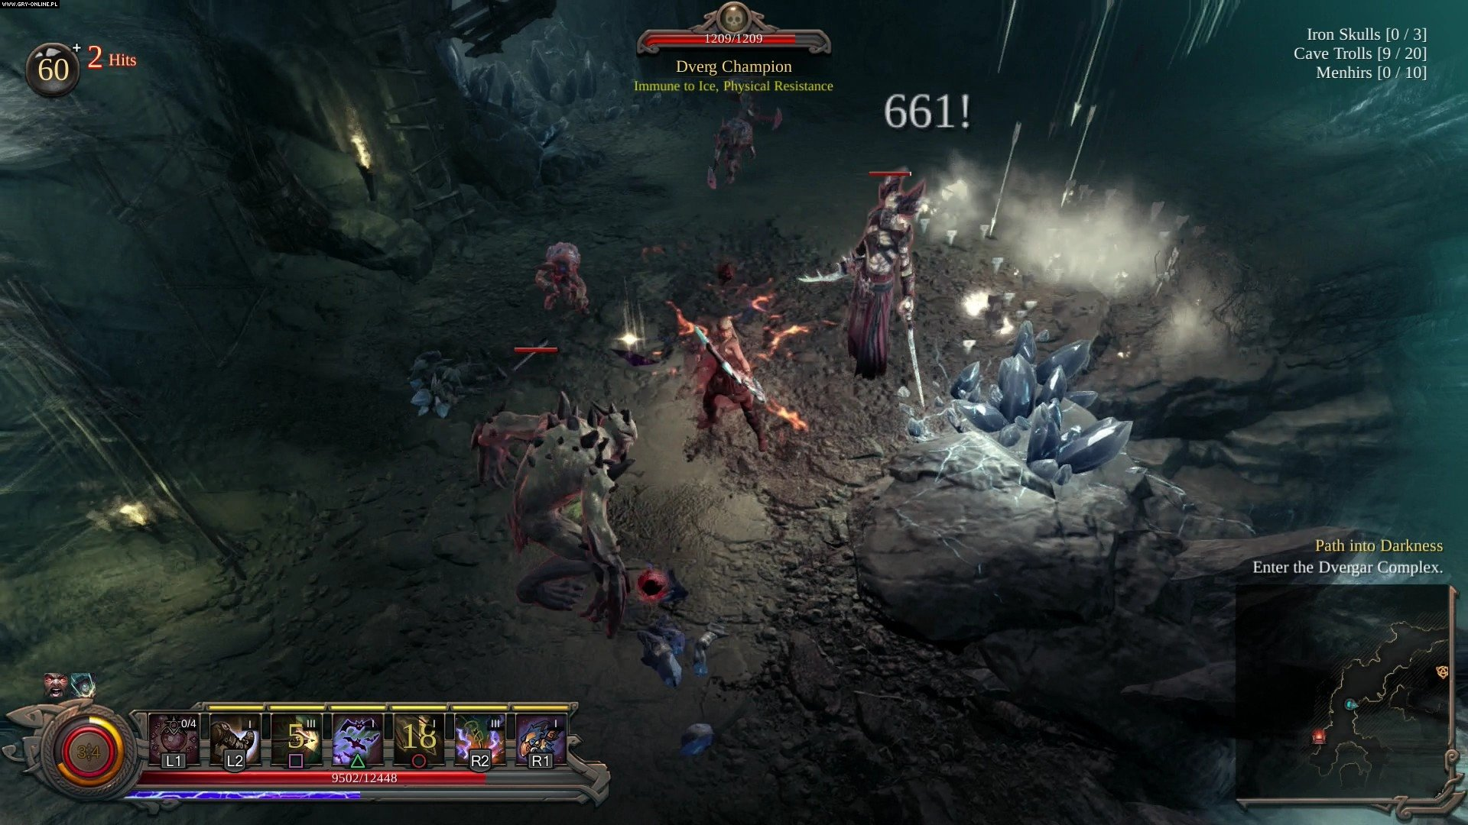

|  |  |
| --- | --- |
|  |  |

With these images of characters, enemies, people, monsters…

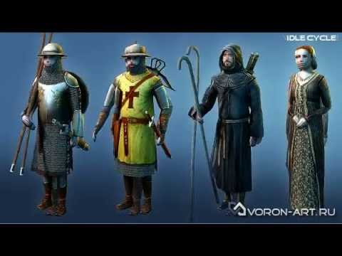 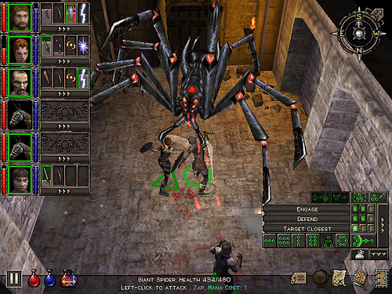



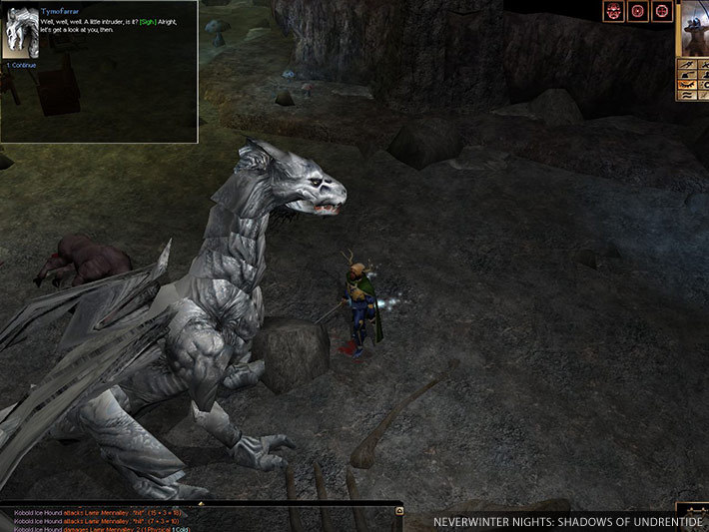

In these settings / locations…

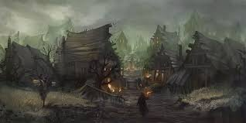

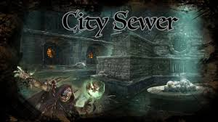

With this sort of polish / effects…

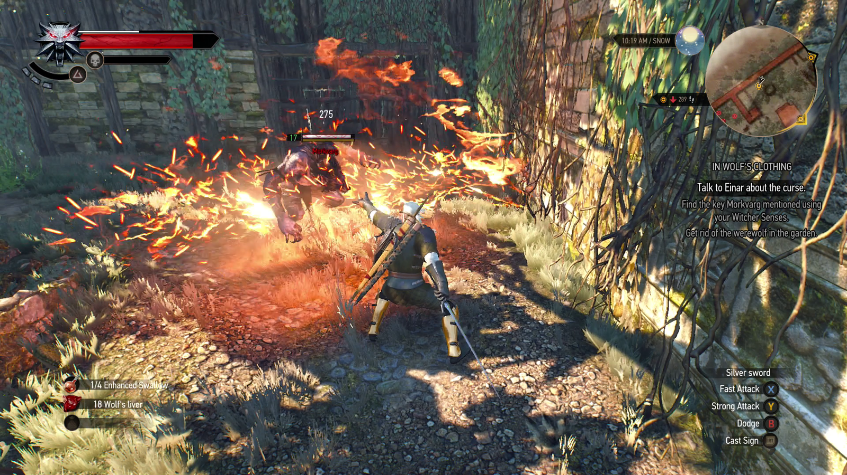

With this type of colour palette…

# More Detailed Explanation



If useful, go through some of the images you that found and particularly liked, highlighting what aspects you like. Eg. the shape of a building, the clothes of a character, the lighting of a room and so on.

You might have 3 images in this section, you might have 30 - put in as many as is useful to yourself or to an artist who might be working on the project with you.